EXPRESSIONS OF INTEREST – Moonee Ponds Central Summer Tunes Busking
Valley Youth and Moonee Ponds Central are currently organising The Summer Tunes - Friday Busking sessions which will be run over summer!
We are planning regular Friday evenings of live music and will be kicking things off on Saturday November 30, 2019 to celebrate the start of the Holiday Season.
We are looking for performers for the regular Friday sessions, as well as the opening on Saturday!
The events will showcase busker-style performers in the public space and potentially lead to repeat or other gigs!

PERFORMER CALLOUT
We are looking for young performers interested in doing sets. This is a paid opportunity for exposure and to be part of creating a fun and inviting environment for young people within the community.
The ​type of performers ​we are looking for are:
- Solo performer
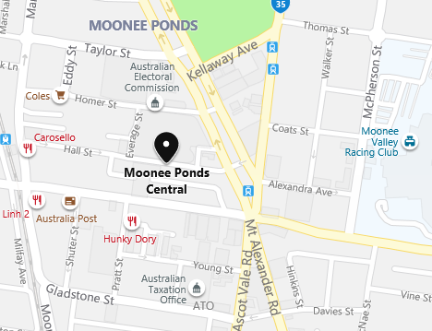
- Duos
- Anyone that can do a busking style set up

THE SITE
MOONEE PONDS CENTRAL
25 HALL STREET, MOONEE PONDS
DATES OF EVENTS
Summer Tunes opening event: Saturday November 30
4:00-6:00 pm (exact times TBC)
Then most Fridays December 2019- February 2020, between 5:00 pm and 6:30 pm (TBC) (no performances over Christmas and New Year)
APPLICATION SUBMISSION DEADLINE
For Summer Tunes Opening event – Wednesday 20 November 4pm
For Friday Summer Tunes Busking - ongoing over the summer period

WHO IS ELIGIBLE TO SUBMIT?
- Aged between 16 - 25
- Those who live, work, study or hangout in Moonee Valley
HOW TO SUBMIT?
Please email bridgetrosegh@gmail.com with the below application form completed and a link to a recording or video of yourself / your group.

WHAT HAPPENS NEXT?

- All submitted performer applications will be assessed by youth consultants
- All applicants for the Saturday Opening event will be responded to by ​Thursday November 21, 2019 ​
- On Wednesday November 27 2019​, all performers for the Saturday Opening event are required to attend a performer briefing session – date and time to be confirmed by the youth consultants
- Applications for Summer Tunes - Friday Busking evenings will be open over summer
- Successful applicants will be allocated a performance time and emailed all necessary documents

PERFORMER EQUIPMENT AND PAYMENT INFORMATION
- Some equipment is available for free hire if required
- Performers will be compensated.
- All performers are allowed to leave an instrument case/cap/equivalent to receive money from the public for their performance if they wish, as the event is a “busker-style” event. Performers take responsibility for any money left in their case.
TERMS AND CONDITIONS
- This event is strictly drug, alcohol and smoking free
- Performances of a discriminatory, explicit or defamatory nature are not suitable for this event and will not be considered
- There will be ​no venue hire costs​ for performers
- Photo Release: ​All performers involved in the event may be photographed or filmed by an event photographer or videographer. Footage/images will be used for the purpose of documenting and promoting activities or for other Valley Youth/Moonee Valley City Council publicity. These photos may be used in ​publicity flyers, posters, articles, and advertisements in newspapers ​ as well as on the Valley Youth website​ or anywhere else Valley Youth/ Moonee Valley City Council may have their programs promoted or recorded.
- Event/Crowd Safety: ​Dangerous activity will not be permitted at this event. In the interests of safety, artists / performers are required not to encourage dangerous behaviours. Artists / performers will assist event management by following all instructions in regards to public safety issues.

EXPRESSIONS OF INTEREST – APPLICATION
Full name:

Preferred performance: Opening event / Friday Busking

Age:
Email address:

Contact number:

Connection to Moonee Valley: (50 words)
Please list area e.g. Ascot Vale, and whether you live, study, work or hang out there.

Performer biography: (100 words)
Tell us a bit about yourself or your group

Performer/group title:
Names of group members:

Performance type/ genre:
Hip Hop/Rap artist, small dance crew, comedian, spoken word poet, solo artist, acoustic rock

Does your performance require extra equipment as part of its setup:
For example if you need to play a pre-recorded track from a laptop as part of a dance performance

Preference of set length:
Maximum 1 hour

Please provide the following:
Facebook page link -
Instagram page hashtag -
Attachment/link to preferred image for social media promotion –

This is to be able to tag you in social media posts about the event for exposure. Please note we are unable to access images shared via Google Drive or Dropbox.

