**Rainbow Valley Newsletter – February 2021**

A big hello to all at Rainbow Valley,

Wishing everyone a good start to 2021! My name is Kathleen, and I’m the Mental Health and Wellbeing Officer at Valley Youth. As you all may be aware Jess Trevena, who normally sends out these updates, moved on from the organisation last month. Until we have a new worker on board, I’ll be the point of contact for Rainbow Valley – so please reach out if you need anything!  
  
I wanted to send out some opportunities to stay connected in the coming months, as well as provide you all with an update!   
  
Though we were hoping to resume in person activities in February, due to current restrictions and delays in staff recruitment, Rainbow Valley group is still on hold for the moment.   
  
In the meantime, there are other local programs you may want to check out, including [QSpace](https://www.rainbownetwork.com.au/directory/qspace) in Glenroy and [Crystal Queer](https://brimbankyouth.com/programs/crystal-queer/) in Sunshine. QSpace meets on the 3rd Wednesday of every month, and Crystal Queer meets every second Thursday from 4-6pm. We’d also like to share the below social events, which we encourage you to get involved in!

**Crystal Queer meetup**   
*Thursday the 25 February* @ *4:30pm-7pm*   
Join Crystal Queer, Brimbank Youth’s LGTBIQIA+ youth group, to view a film from the Mardi Gras Film Festival! Showing on screen will be *The Adventures of Wolf Boy* and subject to time *Anne +.* Please ensure you bring and wear a mask to the session and seating will be social distanced. Email Jacob Tiauli ([JacobT@brimbank.vic.gov.au](mailto:JacobT@brimbank.vic.gov.au)) to sign up!  
Where: Auditorium at the Visy Cares Hub (BLF) in Sunshine.  
  
**Queer Film Festival**  
*18 February - 4 March*  
If you can’t make it to view in person with Crystal Queer– don’t worry! Select films are screening online, available nationally for the first time.‍ Discover the program at [queerscreen.org.au](https://protect-au.mimecast.com/s/WchxCk81wlTEm4Qi9EVpk?domain=queerscreen.org.au/)   
  
**Minus 18 Formal***27 February @ 7pm*  
Minus 18 is taking their annual [Sydney Queer Formal **online**](https://protect-au.mimecast.com/s/j2j3CwV1EAFm1v2sVMbvT?domain=minus18-org-dot-yamm-track.appspot.com) in 2021! That also means **all** LGBTQIA+ young people can attend no matter their location.

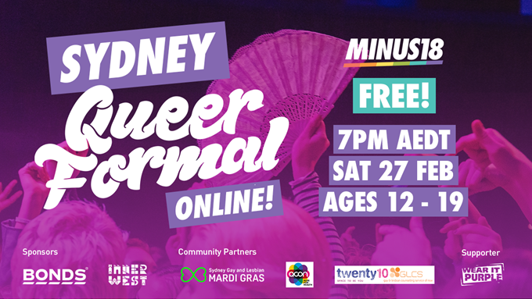

**Valley Youth Consultants’** **Picnic in the Park**  
*20 March, 2-5pm*The Valley Youth Consultants welcomes all young people (12-25) in Moonee Valley to join for Picnic in the Park! Featuring live music by local artists from Moonee Valley, entertainment, and guest speakers from [batyr](https://www.batyr.com.au/) who will be facilitating discussion around wellbeing.  
Where: Queens Park, Moonee Ponds on the grass area closest to the Civic Centre (9 Kellaway Avenue)

RSVP essential – find our more and register via [this link](https://www.eventbrite.com.au/e/valley-youth-picnic-tickets-137561045791).

If you’d like to link in with our wellbeing support, please email [youth@mvcc.vic.gov.au](mailto:youth@mvcc.vic.gov.au) or fill in a request for support here: <https://valleyyouth.org.au/support/> and a staff member will be in touch.  If you need urgent support please contact the Kids Helpline on 1800 55 1800 or access help online at <https://headspace.org.au/eheadspace/connect-with-a-clinician/>

Don’t hesitate to get in touch if you’ve got any questions. Hope everyone has a wonderful weekend ahead!