Hello wonderful people, let me hit you straight off the bat with my meme of the week:

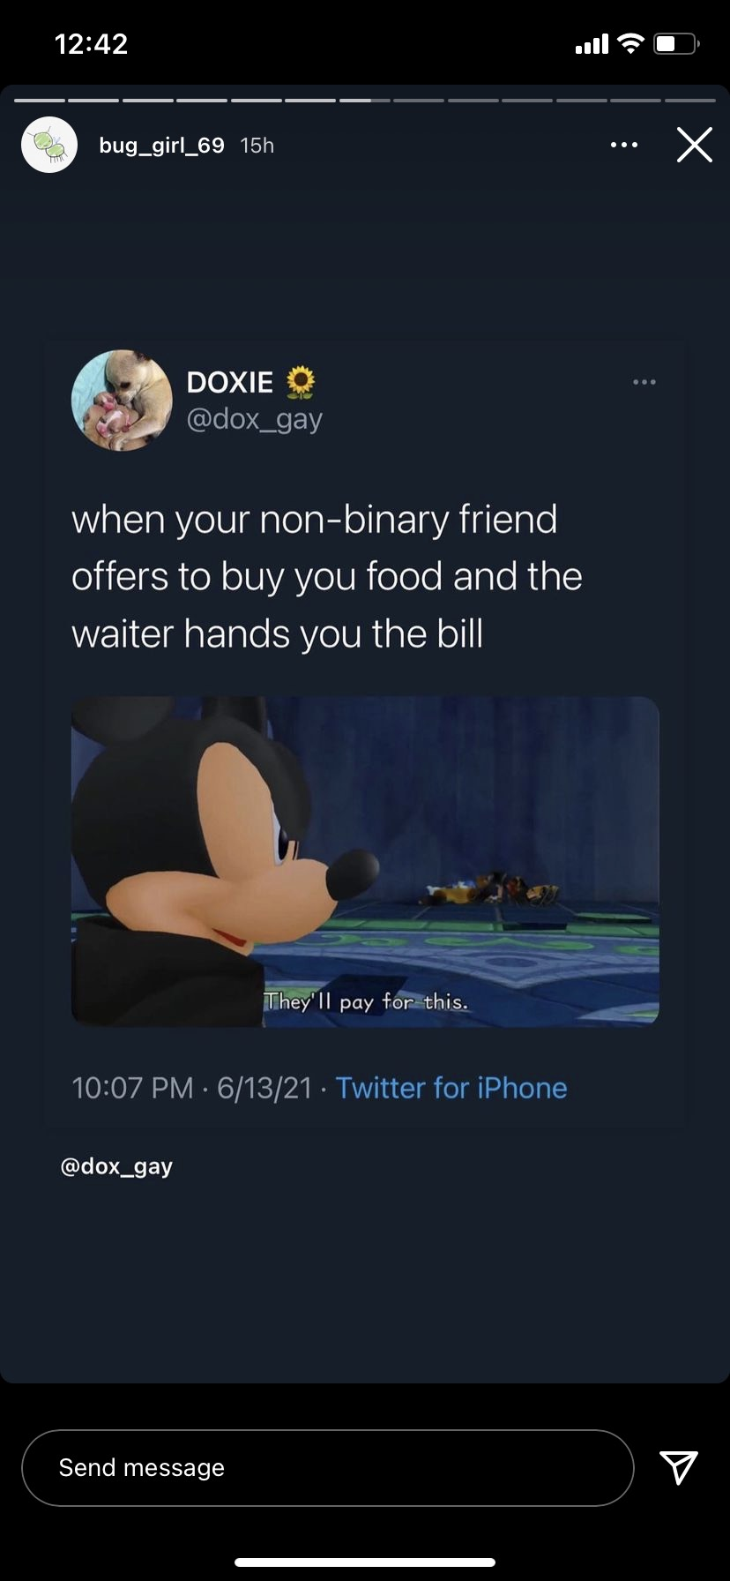

It’s Mon here, with a (belated) happy **international non-binary people’s day** for July 14th!! Sending love and warm and fuzzies to all my enby friends today and every day of the year tbqh.

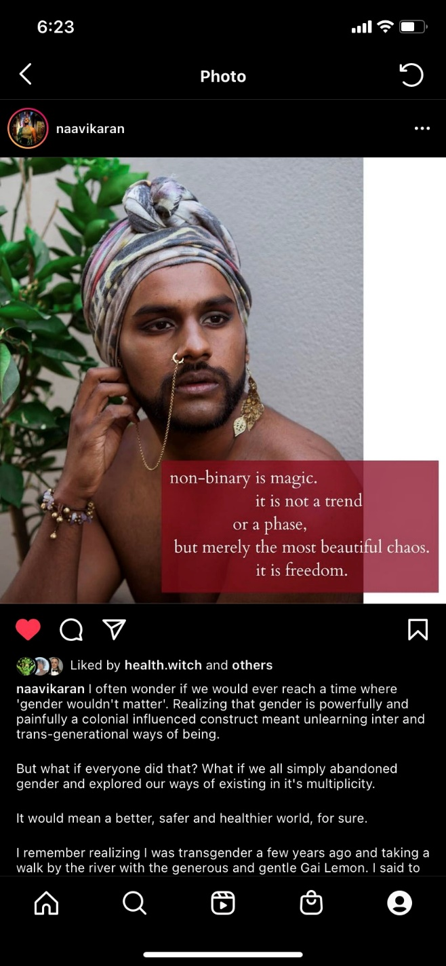

From [@naavikaran](https://www.instagram.com/naavikaran)

I found a fab set of infographics on insta that you can share with a mate (or two or three!) who might not be in the know on all things ~ non binary ~ from [@biminibabes](https://instagram.com/biminibabes):

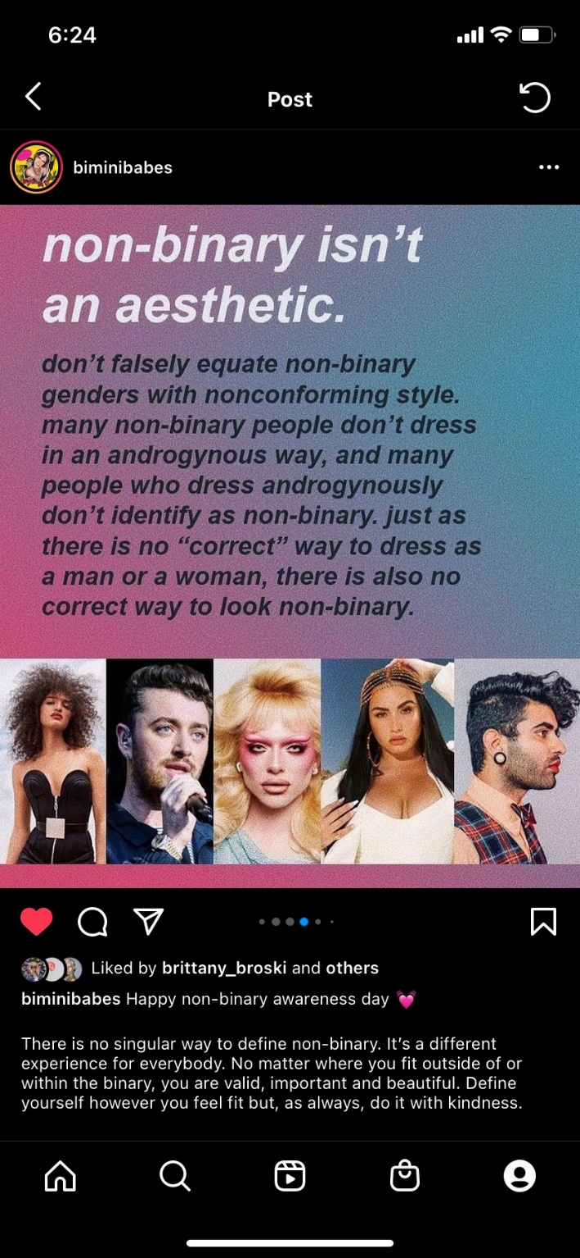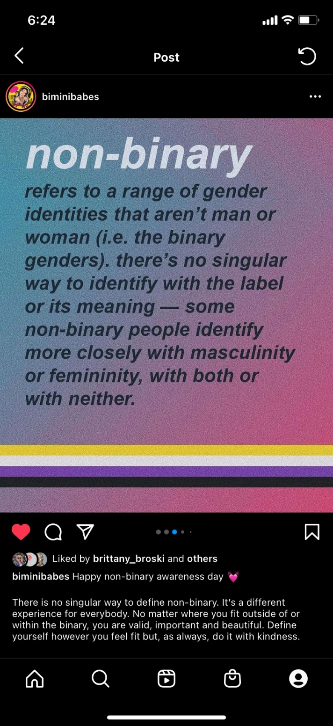

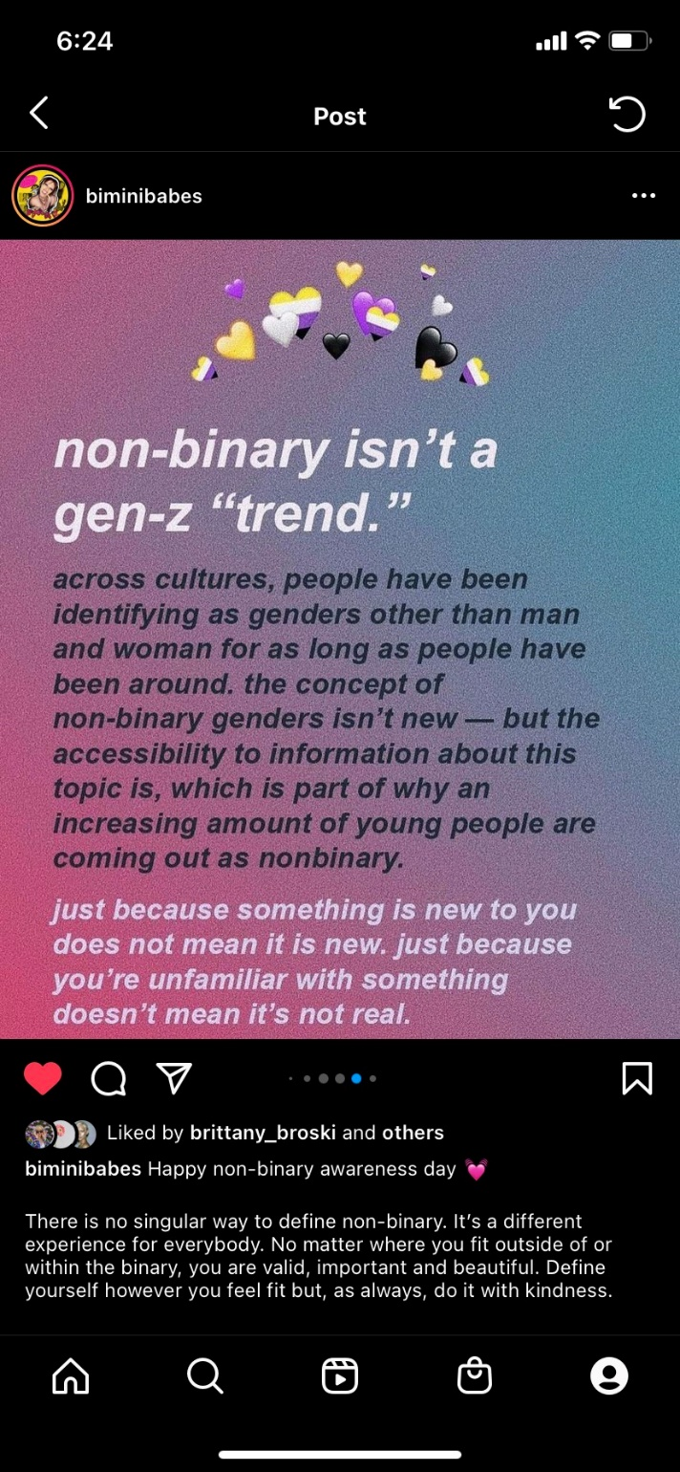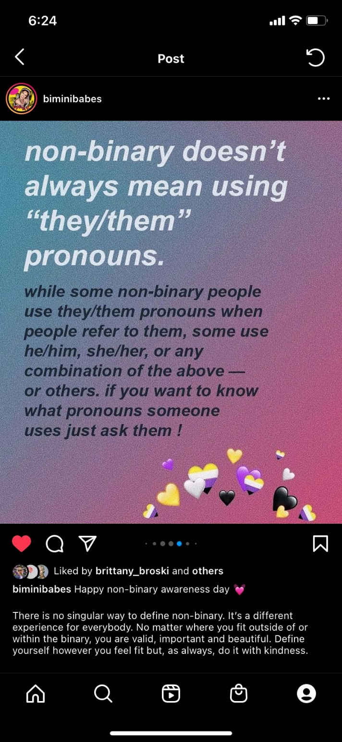

“There is no singular way to define non-binary. It’s a different experience for everybody. No matter where you fit outside of or within the binary, you are valid, important and beautiful. Define yourself however you see fit but, as always, do it with kindness.”

And with news that Melbourne is headed back into lockdown for the next five days, I’ve whipped together a (by no means exhaustive and comprehensive) list of ideas for things to do:

**When’s the next Rainbow Valley?**

Next Rainbow Valley will be held online.

**When:** Last Friday of the month - 30th July 2021. 4:30pm – 6:00pm  
**Where:** Zoom link to be distributed closer to the date.

If you’re interested in coming along, please send me an email or a text to 0408 110 487.

**Wellbeing Support**

At this point I know we’re starting to sound a bit like a broken record, but still! A reminder that it is normal to feel all the big feels (sad, distressed, worried, confused, scared or angry) that the COVID-19 pandemic brings along with it.

If you're struggling or you're feeling concerned about some changes in your behaviour, there are [things you can do that may help](https://www.orygen.org.au/About/Responding-to-the-COVID-19-outbreak/For-young-people-and-families/I-m-struggling-What-can-I-do). I’ve also attached some resources from headspace and orygen which are a great starting point for working through some of the big feels. If you need more immediate support:

**Lifeline 13 11 14**

**Kids Helpline 1800 55 1800**

**Eheadspace** <https://headspace.org.au/eheadspace/connect-with-a-clinician/>

If you’d like to link in with Valley Youth’s wellbeing support, please email [youth@mvcc.vic.gov.au](mailto:youth@mvcc.vic.gov.au) or fill in a request for support here: <https://valleyyouth.org.au/support/> and a staff member will be in touch.

Sending all the lockdown solidarity and love I can muster for the next few days,

**Mon** from the Valley Youth team